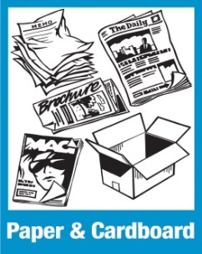
What to Recycle
- Newspaper, inserts, magazines, books, catalogs, phone books, office paper, mail, envelopes, gift wrapping paper
- Cardboard (flattened)
- Cereal , cracker, cookie, etc. boxes

NOT RECYCLABLE
- Styrofoam
- Oil product containers
- Syringes
- Plastic Bags

- Paper or cardboard with food on it.

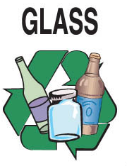
- Clear, brown or green bottles and jars
- Soda, beer, wine, juice or other glass
- food containers

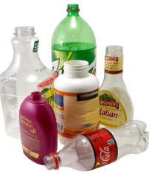
PLASTIC
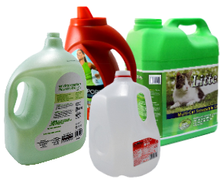

- Plastic jugs and bottles only
(gets smaller toward the top)
- Milk jugs, soda bottles, laundry products, etc.
- Please remove all lids

Helpful Recycling Hints
- Empty recyclables out of bags before putting in recycling bins
- Please rinse all cans and containers
- Put recyclables in the correct location in recycling bin
- No household trash in recycling bins
- REMOVE LIDS from bottles

NOT RECYCLABLE

- Paper or cardboard with food on it.
NOT RECYCLABLE

- Paper or cardboard with food on it.

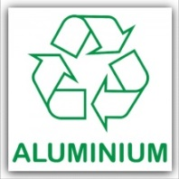
- Soft drink/Beverage cans
- Pie and cake pans
- Aluminum foil
- Vienna sausage and sardine cans
NOT RECYCLABLE

- Needles
NOT RECYCLABLE

- Paper or cardboard with food on it.

. 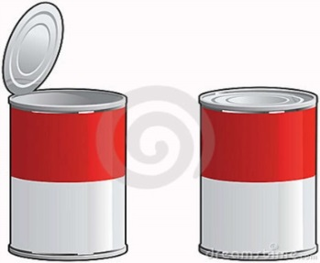
CANSNNNS
TIN
- Tin cans (cat & dog food cans)
- Fruit and vegetable tin cans
- Soup cans
- Empty aerosol cans

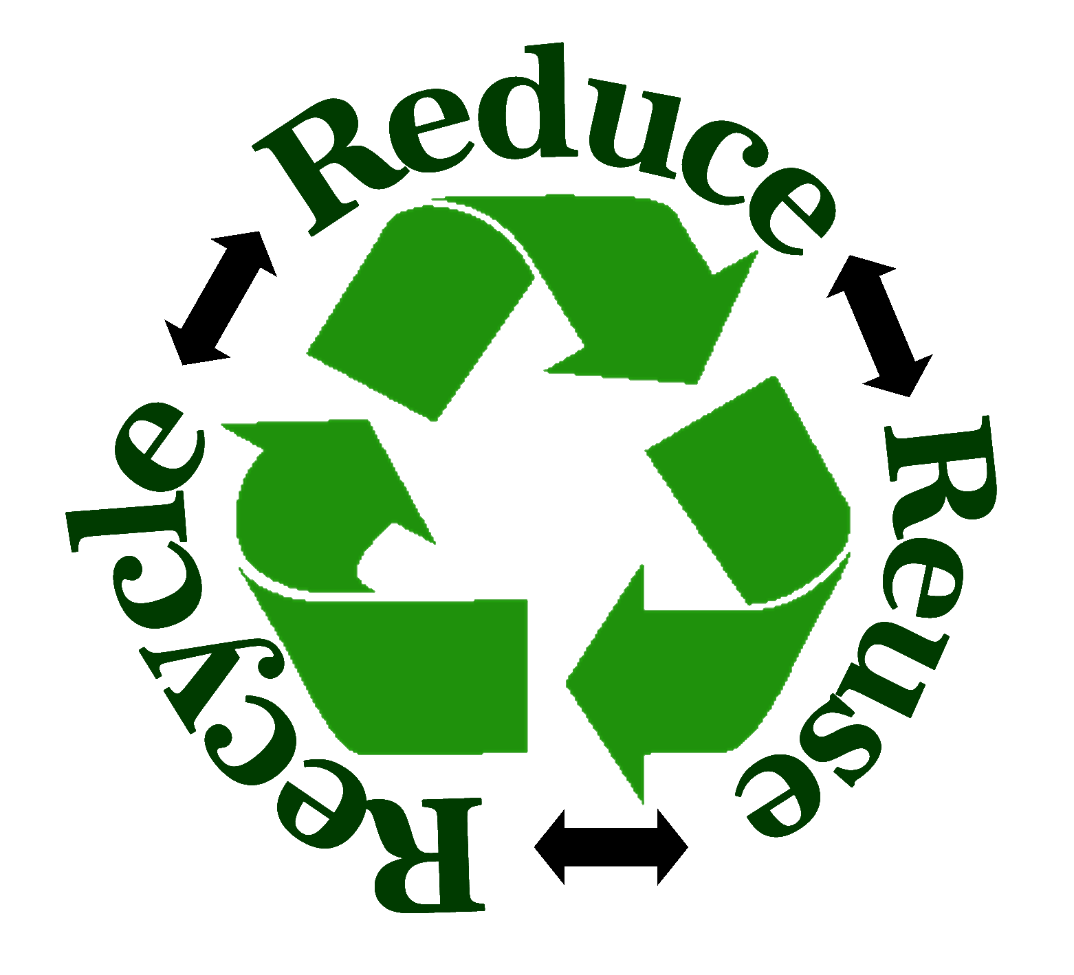
NOT RECYCLABLE

- Light bulbs
- Fluorescent tubes
NOT RECYCLABLE

- Paper or cardboard with food on it.

County Recycling Collection Stations
Cedar Creek/Zepp – 6471 Zepp Rd., Maurertown

Conicville – 922 Conicville Rd., Mt. Jackson

Edinburg (Landfill) – 249 Landfill Rd. Edinburg

Ft. Valley – 6296 Woodstock Tower Rd. Ft. Valley

Maurertown–25360 Old Valley Pike, Maurertown

Orkney Springs –3896 Orkney Spring Rd. Orkney

Quicksburg – 3277 River Road, Quicksburg

Rodney & Theresa –2984 Wolf Gap Rd. Edinburg

Strasburg - 321 Powhatan Road, Strasburg

Route 263 – 8837 Orkney Grade, Mt. Jackson

Rudes Hill – 4874 Old Valley Pike, Mt. Jackson

Woodstock – 200 Moose Road, Woodstock

The following items are accepted for recycling in designated areas at the Landfill property:

- Brush, wood products, lumber, or yard waste such as leaves or grass clippings.

- Waste automotive products such as used petroleum/oil and antifreeze. (from homes only)

- Vehicle batteries

- Larger aluminum products.

- Scrap metals of all kinds.

- Appliances, including refrigerators, freezers, stoves, ovens, ranges, washers, dryers and microwaves.

- Electronics: monitors and tv’s (fee charged) and computers

- Waste tires. Fee charged.



Fun Facts

Recycling one aluminum can saves enough energy to power a TV for up to three hours.
It can take up to 700 years for plastic to decompose (break down) in a landfill.
One ton of paper recycled saves more than 3.3 cubic yards of landfill space.
Americans use 2,500,000 plastic bottles every hour! Most of them are thrown away!

Hours of Operation

Landfill: Monday-Saturday
8:00a.m. – 4:00p.m.

Citizen Sites: Monday, Tuesday,
Wednesday,
Friday and Saturday
7:00a.m. until 7:00p.m.

Closed on Thursday

Sunday
1:00p.m. until 5:00p.m.

RECYCLING GUIDE

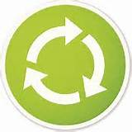

SHENANDOAH COUNTY
~~~~~~~~~~~~~~~~~~~~~~~~~~~~~~~~~~~~~
For more information please call
540-984-8573
Or visit our website www.shenandoahcountyva.us/landfill
~~~~~~~~~~~~~~~~~~~~~~~~~~~~~~~~~~~~~

