Shenandoah County Fire & Rescue


ENGINE DRIVER RELEASE PROGRAM

Phase I
- Complete certification at the VDFP Engine Driver/Pump Operator Level.

- Completion of “Non-Emergency” Driving time -
Candidates shall complete 10 hours of “Non-Emergency” driving hours with an approved instructor. These hours are documented in the SCFR Engineer candidate packet. These hours are used to develop a level of comfort before moving on to “Emergency” driving time. These hours are also a good opportunity for the candidate to learn his or her first due area, target hazards, and hydrants and/or other water sources available.

- Completion of Emergency Driving Time -
Candidates shall complete 10 “Emergency” mode driving responses with and approved instructor. These calls shall be documented in the SCFR Engineer Candidate packet. It is preferred to use EMS calls to complete this potion to allow the D/O Candidate to focus on driving in “Emergency Mode” only and not the Pump Operator portion of the process.

- Completion of VDFP DPO Scenarios -
Candidates shall complete the seven VDFP DPO scenarios in a satisfactory manner with an approved instructor.

- Completion of the SCFR DPO Written Test -
Candidates shall complete the SCFR DPO written test and score a minimum of 80%.

Candidates who successfully complete Phase I are eligible to be awarded “Engineer Status” for Shenandoah County Fire & Rescue.

Phase II

- Candidates shall complete in house training established by the Station Commander used to familiarize the candidate with the following.
- Each Engine to be operated in that Station
- All Equipment carried on Engines in that Station
- First Due Area
- Station Level Testing - Candidates shall complete the following tests to demonstrate their knowledge and skill as a D/O.
- 20 Question Written test on each Engine and Specific Equipment carried on that Engine. Candidates must score 100%.
- Street/First due Familiarization Testing using at least 10 separate First Due Area Streets.
- At least three Random Practical Scenarios using a specific Engine and/or Equipment Carried on that Engine.
- Engine Familiarization Practical Testing. Testing on at least Six different Items or Nuances Specific to that Engine.

Shenandoah County Fire & Rescue Engineer Certification Practical Sheet

NAME: DATE:
These scenarios are designed to ensure competence in engine operations.
All scenarios and each task must be performed or communicated to the satisfaction of the company officer for the employee to pass.
Scenario 1 = Pumper
Produce effective handline streams, given the sources specified in the following list so that the pump is engaged, all pressure control and vehicle safety devices are set, the rated flow of the nozzle is achieved and maintained, and the apparatus is continuously monitored for potential problems: (1) Internal tank, (2) Pressurized source, (3) Static source (4) Transfer from internal tank to external source

Follow all operating procedures expected on the fire ground.
- Spot engine to hydrant.
- Engage pump, set transfer valve (if applicable)
- Operate tank to pump valve.
- Pump engine at delivery rate of hose pulled (attack line).
- Connect supply hose and gate valve to hydrant.
- Open hydrant - open master intake valve.
- Switch from tank to hydrant w/ min. fluctuation (Note static).
8. Flow additional line (2 ½”) at correct pressure.
9. Set pressure relief valve
10. Top off water tank (tank fill).
11. Slowly shut down.

Date: / / | Instructor:

Scenario 2 = Portable and/or Elevated Master Stream
Produce effective master streams, given the sources specified in the following list so that the pump is engaged, all pressure control and vehicle safety devices are set, the rated flow of the nozzle is achieved and maintained, and the apparatus is continuously monitored for potential problems: (1) Internal tank, (2) Pressurized source, (3) Static source (4) Transfer from internal tank to external source

Follow all operating procedures expected on the fire ground.
- Supply ladder pipe if available with different tips.
- Supply portable master stream w/ different tips.
- Employ different hose lays as supply. (i.e. single 4”, dual 3”)

Date: / / | Instructor:

Scenario 3 = Relay Pumping
Pump a supply line 3” or larger in a relay pumping evolution, taking into consideration the length and size of the line and the desired flow and intake pressure, so that the correct pressure specifications and flow are provided to the next pumper in the relay.

Follow all operating procedures expected on the fire ground.
1. First engine proceeds to target; deploy and flow lines.
2. Second engine lays from the first Engine to a hydrant or water supply and supplies water to the attack engine.
3. If manpower or multiple apparatus are not available, you may simulate attack engine and supply line by utilizing a nozzle and a discharge on the “supply” engine.

Date: / / | Instructor:

Scenario 4 = Foam
Produce a foam fire stream, given foam-producing equipment, so that properly proportioned foam is provided.

Follow all operating procedures expected on the fire ground.
1. Perform and demonstrate use of a foam eductor and air-aspirating nozzle.
2. Flow foam from the on-board foam system. (If applicable)
3. Demonstrate proper knowledge in foam classes and their respective uses and percentages.
Date: / / | Instructor:

Scenario 5 = Drafting
Produce effective hand or master streams, given the sources specified in the following list so that the pump is engaged, all pressure control and vehicle safety devices are set, the rated flow of the nozzle is achieved and maintained, and the apparatus is continuously monitored for potential problems:
- Internal tank, (2) Pressurized source, (3) Static source (4) Transfer from internal tank to external source.

Follow all operating procedures expected on the fire ground.
- Position pumper for drafting.
- Attach hard sleeve and strainer.
- Make sure adequate amount of water is around the strainer.
- Adjust transfer valve (if applicable).
- Engage pump / increase rpm’s.
- Listen for water entering the pump.
- Charge handline to desired pressure.
- Charge second handline to desired pressure.
- Set pressure relief valve (if applicable).
- Refill tank (if applicable).
- Slowly shut down.
Date: / / | Instructor

Scenario 6= Supply a Stand Pipe
Supply water to a fire standpipe system, given specific system information and a fire department pumper, so that water is supplied to the system at the correct volume and pressure.

Follow all operating procedures expected on the fire ground.
Personnel shall hook up to a standpipe system. (Simulate as necessary)
- Locate the fire department connection.
- Connect hoseline(s) to the FDC.
- Establish Water supply from appropriate hydrant and note static pressure.
- Charge the standpipe system to the appropriate pressure.
Do not exceed 200 psi.
- Slowly shutdown standpipe operations.

Date: / / | Instructor:
Scenario 7 = Support a Sprinkler System.
Supply water to a fire sprinkler system, given specific system information and a fire department pumper, so that water is supplied to the system at the correct volume and pressure.
Follow all operating procedures expected on the fire ground.
Personnel shall hook up to a sprinkler system. (Simulate as necessary)
- Locate the fire department connection.
- Connect hose line(s) to the FDC.
- Adjust transfer valve (if applicable)
- Charge the sprinkler system to the appropriate pressure (150 psi)
- Establish water supply from appropriate hydrant and note static pressure.
- Transition from booster tank to hydrant.
- Refill booster tank (if applicable)
- Maintain pressure of 150 psi for the duration of the incident (may verbalize).
- Slowly shutdown sprinkler operations.
Date: / / | Instructor:

Street Training
Company 23 Company 21/13 Company 18
1. Ashby Lane | 1. Main St. | 1. Alum Springs Road
2. Burkholder Lane | 2. Old Valley Pike | 2. Orkney Springs Road
3. Cadet Road | 3. Orkney Grade | 3. Happy Valley Road
4. Clicks Lane | 4. Conicville Blvd. | 4. Resort Drive
5. Dixie Lane | 5. Red Banks Road | 5. Crooked Run Road
6. Confederate St. | 6. Senedo Road | 6. Fairway Drive
7. Lee Hwy. | 7. Conicville Road | 7. Orkney Grade
8. Lee Street | 8. South Middle Road | 8. Mill Creek Road
9. Old Cross Road | 9. Swover Creek | 9. Hepner Road
10. George R. Collins Pwky. | 10. Headquarters Road | 10. Supinlick Ridge Road
11. John Sevier Road | 11. Jerome Road | 11. Willow Lane
12. Congress St. | 12. Supinlick Ridge Road | 12. Dawn Drive
13. Shenvalee Drive | 13. Caverns Road | 13. Ellen Drive
14. Smith Creek Road | 14. Moreland Gap Road | 14. Palmer Road
15. Shenandoah Drive | 15. Turkey Knob Road | 15. Straton Way
16. Stonewall St. | 16. Bryce Blvd. | 16. Miller Road
17. Stuart Street | 17. Lonas Street | 17. Liberty Furnace Road
18. Exit 264, I-81 Interchange | 18. Broad Street | 18. Killmon Drive
19. Exit 257, I-81 Interchange | 19. Belgravia Road | 19. Lee Road
20. I-81 Median Cross Overs | 20. Bethel Church Road | 20. Beauregard Drive

Company 9 Company 51
1. Old Valley Pike | 1. King Street
2. Zepp Road | 2. John Marshall Hwy
3. Saumsville Road | 3. Bowman Mill Road
4. Back Road Road | 4. Capon Street
5. Mt. Olive Road | 5. Queen Street
6. Mt. Hebron Road | 6. Washington Street
7. Millner Road | 7. Oranda Road
8. Battlefield Road | 8. Clary Road
9. Artz Road | 9. Quarry Lane
10. Toll House Rd | 10. 296 and 298
11. Copp Road | 11. I-81 Crossovers
12. Creek Road | 12. Waverly Drive
13. Zion Church Road | 13. Junction Road
14. Jessica Place | 14. Back Road
15. Mauretown Mill Road | 15. Middle Road
16. Maddie Byrd Park | 16. Hite Lane
17. I-81 and Crossovers | 17. Borden Mowery Drive
18. Tea Berry Ct. | 18. Virginia Street
19. Black Bear Road | 19. Stonewall Street
20. Ridgley Road | 20. Water Street

DATE | HOURS | ROAD SURFACE TYPE | INSTRUCTOR
DRIVE TIME

EMERGENCY RESPONSE (EMS)

DATE | INC. NUMBER | INSTRUCTOR

Shenandoah County Fire & Rescue Pump Operator Certification Application

___________________________ has successfully met all requirements listed below to be released as a Pump Operator in Shenandoah County. The individual understands that driving apparatus is a privilege that can be revoked at any time for reasons that question his/her abilities as an operator.

Phase I
Obtain VDFP DPO Certification
Completion of Non-Emergency Drive Time
Completion of Emergency Drive Time
Completion of VDFP DPO Scenarios
Score a Minimum of 80% on SCFR Pump Ops Test

Employee Signature: ________________________________ Date: _____________

Supervisor Signature: ________________________________ Date: _____________

Shenandoah County Fire & Rescue



Pump Manual

October 2017
Table of Contents
- Pump Terminology…………………………………….…………2
- Engaging the pump………………………………………….…..5
- Beginning Operations……………………………………………6
- Nozzle Pressures & GPM’s…….………….………………….7
- Hydraulic Calculations…………………………….……………9
Tip Sizes & GPM’s
Coefficient Friction Loss
Condensed “Q” formula
Hand Method
- Hydrant Operations……………………………………………15
Hydrant color codes
Available water supply
- Drafting Operations…………………….……………………..18
- Foam Operations………….…………………………………….20
9) Special Considerations…………………..……………………21
Sprinkler systems
Standpipe Operations
Ladderpipe Operations
Direct fill intakes
Maintenance

Page 1

Pump Terminology
Appliances: Generic term applied to any nozzle, wye, Siamese, deluge monitor, or other piece of hardware used in conjunction with fire hose for the purpose of delivering water.

Bleeder Valve: Valve on a gate that allows air to be bled from a supply line before entering the pump. Can be automatic or manual, depending on the apparatus.

Compound (Intake) Gauge: Gauge capable of measuring positive pressure (PSI) or negative pressure (Inches of mercury, HG). Term used to describe the gauge that measures the intake pressure on a fire pump.

Discharge Valve: Valve used to move water from the pump into the hose.

Drain Valve: Valve on pump discharge that facilitates the removal of pressure from a hose line after the discharge has been closed.

Engine Pressure (EP): Highest pressure that is being produced by the pump.

Foam: Extinguishing agent formed by mixing a foam concentrate with water and aerating the solution for expansion; for use on Class A and Class B fires. Foam may be protein, synthetic aqueous film forming foam (AFFF), high expansion, or alcohol type.

Friction Loss (FL): Loss of pressure created by the turbulence of water moving against the interior walls of the hose, pipe, appliances, ect.

Intake Valve: Valve that is used to allow water into the pump.

Intake relief valve: Valve designed to prevent damage to a pump from water hammer or any sudden pressure surge.

Lift: Distance between the surface of the water and the centerline of the pump.

Page 2

Master (discharge) Gauge: Gauge used to show the highest pressure being produced by the pump.

Master Stream: Any water stream that flows greater than 350 gallons per minute.

Multi stage pump: Centrifugal pump with two impellers. Has capability to pump with one impeller (pressure or parallel mode), or use two impellers when flow is over 50% of the pumps rated capacity (volume or series mode)

Net Pump Discharge Pressure: Difference between discharge and intake pressure. Actual pressure that is being produced by the pump.

Nozzle Pressure (NP): Pressure at which water is discharged from the nozzle.
Primer: Small positive displacement pump used to evacuate air form a centrifugal pump housing and hard suction hose, thus allowing the pump to receive air from a static water source.

Pressure Governor: Pressure control device that controls engine speed (RPM) thus eliminating hazardous conditions caused by excess pressure.

Pressure Relief Valve: Automatic device designed to release excess pressure from the fire pump back into the intake side of the pump.

Power Take Off (PTO): Rotating shaft that transfers power from the engine to auxiliary equipment. Pumps may also be PTO driven which allows the apparatus to pump and drive at the same time.

Pump Discharge Pressure (PDP): Pressure being discharged for an individual line as it leaves the pump and enters the hose.

Pump Shift Override: Allows the operator to bypass the electric pump shift and still engage the pump manually, located on the pump panel.

Residual Pressure: Pressure that is left over in a water system after flowing water.

Page 3

Single stage pump: Centrifugal pump with only one impeller.

Stabilizer Knob: Stabilizes gauges on a pump panel while flowing water, found on older apparatus and rigs without liquid filled gauges.

Static Pressure: Water Pressure available in a water system prior to water flowing.

Steamer connection: Large diameter intake, usually 5” on the pump panel. Also considered the centerline of the pump.

Tank to Pump: Valve that allows water to enter the pump from the booster tank. May be labeled differently depending on the apparatus.

Tank Fill: Valve that allows water into the booster tank from an outside water source. Also may be used to circulate water through the pump for cooling purposes when no water is flowing.

Transfer Valve: Valve used for placing multistage centrifugal pumps in pressure (series) or volume (parallel) mode.

Water hammer: Force created by the rapid deceleration of water, usually resulting from closing a valve or nozzle too quickly. Has potential to severely damage the pump and water system.

Page 4

Engaging the Pump

Automatic Transmissions
- Bring apparatus to a complete stop.
- Shift transmission to neutral.
- Set parking brake.
- Operate pump shift control.
- Shift transmission into proper gear for pumping.
- Depress accelerator to ensure shift is complete. (If applicable)

Manual Transmissions
- Bring apparatus to a complete stop.
- Disengage clutch
- Shift transmission to neutral.
- Set parking brake.
- Operate pump shift control.
- Shift transmission into proper gear for pumping.
- SLOWLY engage clutch.

**PTO driven pumps will not require shifting transmission into gear for pump to engage, they have the ability to pump and roll**

To ensure the pump is in gear: (applicable for both manual and automatic transmissions
- Listen for proper transfer
- Check to ensure that the pump indicator light is “ON” (“OK to pump” light)
- If applicable, check the speedometer.
Page 5

Beginning Operations

The following is a list of steps to complete once the pump has been engaged.

- Set the wheel chocks.
- Ensure that the “OK to pump” light is on. (This will be located on the pump panel)
- Open the “Tank to pump” valve.
- Transfer valves should be set at this time for apparatus equipped with two stage pumps.
  - When operating at or above 50% of the pumps rated capacity, the pump shall be set in the volume (parallel) setting.
- Ensure that all hoselines are clear of the hosebeds and secured by a firefighter or device.
- SLOWLY open discharges.
- Increase throttle until desired pressure is reached. *OPERATORS ARE NOT TO EXCEED 250 PSI WITHOUT DIRECT ORDERS FROM COMMAND*
- Set pressure control device (if applicable)
- Obtain secondary water source if applicable.
- Mark static and residual pressures to determine water availability when operating off of a pressurized water source.
- When not discharging water from the pump, be sure to circulate water by opening the tank to pump and tank fill valves.

**Occasionally pumps become “air locked”. This is identifiable by confirming that the pump placed in gear, no water filling the hose when the discharge valve is opened, no reading on the master gauge and the pump making cavitation noises. To remedy this, engage the primer until a steady stream of water exits from the primer discharge tube**

Page 6

Nozzle Pressure
In order to pump at the correct discharge pressure, it is essential that you know what type of nozzle your department carries on the apparatus. There are several different types of nozzles on the market that operate at different pressures, depending on the manufacturer. The following is a list of nozzle pressures for common types of nozzles found.

- With the exception of nozzles designed to operate at lower pressures*, all standard automatic fog nozzles operate at 100 PSI, regardless of handline or master stream.
- All master stream smooth bore or solid stream nozzles operate at 80 PSI.

- All hand line smooth or solid stream nozzles operate at 50 PSI.

Combination Nozzles
Combination nozzles enable the user to switch between a solid stream setting, and a fog setting. The pressures for this nozzle differ from a standard automatic nozzle, in which manufacturers recommendations must be followed for the combination nozzles.

Page 7

** Flow Charts for Akron Saberjet Model 1523 Nozzles

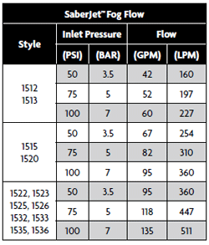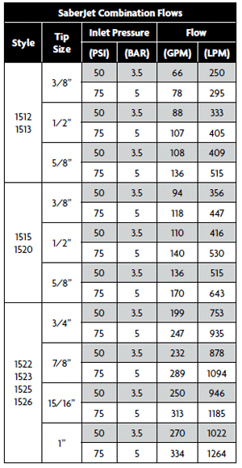

Page 8
Hydraulic Calculations

In order to obtain the correct discharge pressure, use the following formula:

Nozzle Pressure + Friction Loss = Discharge/Engine Pressure.

Tip sizes & GPM’s:
In order to determine the correct friction loss for handlines, the gallons per minute must be determined. The following are the tip sizes and GPM’s for smooth bore tips.
Tip Size | Gallons Per Minute
½” | 53
15/16” | 185
1” | 200
1 1/8” | 250
1 ¼” Handline | 325
1 ¼” Master Stream | 400
1 3/8” | 500
1 ½” | 600
1 5/8” | 700
1 ¾” | 800
1 7/8” | 900
2” | 1000

**Any time when the flow is 350 GPM or greater, 10 PSI must be added for appliances, and 25 PSI must be added for master streams**

** Anytime 350 GPM’s are exceeded from a single device it is considered a master stream**

The following are multiple examples of how friction loss can be determined. Remember, use the method that works best for you.

Page 9

Hydraulic Calculations

Coefficient friction loss method:

Coefficient (C) x Quantity2 (Q2) x Length (L) = Friction Loss (FL)

Coefficient (C) – Found in a predetermined chart (see below)
Quantity (Q) – The total gallons per minute divided by 100
Length (L) – The total length of hose divided by 100

Coefficient Chart
Below are the most commonly used coefficients, additional coefficients may be found in any driver pump operator manual.

Hose Diameter | Coefficient
1 ½” | 24
1 ¾” | 15.5
2 ½” | 2
3” | .8
4” | .2
5” | .08

(Remember to divide the quantity and length by 100)

Page 10

Condensed “Q” Formula

Below lists several ways to calculate friction loss in 2 ½”, 3”, and 4” hose using the Condensed “Q” Formula. The amount of friction loss calculated using this formula will be 20% greater than if the same situation is calculated using FL=CQ2L. (Remember to divide the quantity by 100)

2 ½” Hose
FL = Quantity² x 2
Example: 2 ½” hoseline flowing 250 GPM.
FL = (2.5)² x 2
FL = 6.25 x 2
FL= 12.5 per hundred foot.

3” Hose
FL = Quantity²
Example: 3” supply hose flowing 400 GPM.
FL = (4)²
FL = 16 per hundred foot

Page 11

Condensed “Q” Formula Continued

4” Hose
FL = (Quantity)²
5
Example: 4” supply hose flowing 600 GPM
FL = (6)²
5

FL = 36
5
FL = 7.2 per hundred foot

5” Hose

FL = (Quantity)²
15
Example: 5” supply hose flowing 900 GPM.
FL = (9)²
15
FL = 81
15
FL = 5.4 per hundred foot

Page 12

Fireground/Hand Method
The following are several ways to calculate friction loss utilizing the hand method, and/or fireground method, per hundred foot of hose.

1 ¾” Hose
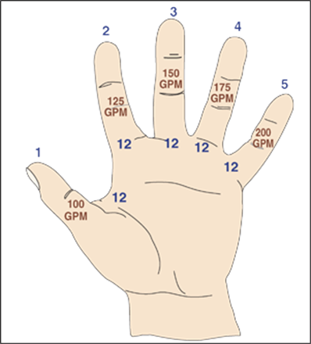
Example:
100’ of 1 ¾” flowing 150 GPM
Find the finger with 150 GPM and multiply the 2 numbers labeled on it.
FL = 12 x FL = 36 per hundred foot.

Page 13
Fireground/Hand Method Continued

2 ½” Hose

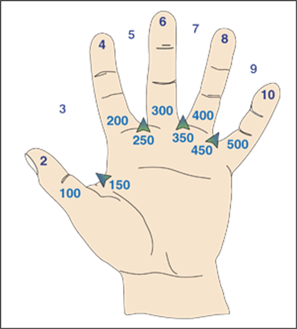
Example:
100’ of 2 ½” hose flowing 250 GPM
Divide the gallons per minute by 100
Find the space with 250 and multiply the two numbers
FL = 5 x 2.5
FL = 12.5 per hundred foot.

Page 14

Supplying Pumpers
When the GPM’s of the attack pumper are known, a residual pressure of 40 PSI will be added to the calculated friction loss.

When the GPM’s of the attack pumper are NOT known, a starting pump discharge pressure of 100 PSI will be used and adjusted accordingly to the attack pumper ‘s needs.

**Always notify command when your tank is half full, and again when empty**

Hydrant Operations

Most hydrants are color coded according to the GPM’s that they flow.

Hydrant Color Coding

Blue Top Hydrants = 1500 + GPM’s
Green Top Hydrants = 1000 - 1499 GPM’s
Orange Top Hydrants = 500 - 999 GPM’s
Red Top Hydrants = 0 - 500 GPM’s

**Never drop below 20 PSI residual pressure when flowing from a hydrant**

Page 15

Available Water Supply
When operating off of a hydrant it is important to know how much more water the hydrant can provide. The following are two ways to determine this.

Percent Drop Method

Percent Drop = (Static – Residual) (100)
Static
0 - 10% drop = 3 times the total GPM flowing
11% - 15% = 2 times the total GPM flowing
16% - 25% = 1 time the total GPM flowing
>- 25% = 0 times the total GPM flowing
Example
Static = 63 Residual = 55
(63 – 55)(100)
63
(8)(100)
63
800
63
= 12.7% (2 times the total GPM flowing)

Page 16

Available Water Supply Continued

First Digit Method
*First Digit Method = Static – Residual
*Multiply the first digit of the static pressure by 1, 2, and 3 to determine water availability ( If static pressure is greater than 100, multiply by the first 2 digits).
*PSI Drop equal to or less than the first digit of the static pressure multiplied by 1, then 3 times the amount of water available.
*PSI drop equal to or less than the first digit of the static pressure multiplied by 2,
then 2 times the amount of water available.
*PSI drop equal to or less than the first digit of the static pressure multiplied by 3,
then 1 time the amount of water available.

Example:
Static = 68 Residual = 52

68
-52
16

1 x 6 = 6 3
2 x 6 = 12 2
3 x 6 = 18 1

16 is less than 18, so therefore you can flow 1 more time the GPM’s that you’re currently flowing.

Page 17

Drafting Operations

- For successful drafting operations the proper draft site must be selected by ensuring the following:
- No more than 10 ft of vertical lift.
- A minimum of 18’’ of water surrounding the strainer on all sides.
- Must be able to park the apparatus close to the water source.
- Once the proper site has been selected, attach the hard sleeve to the pump and ensure the following:
- Hard sleeve should be even or lower than the intake.
- All connections should be tight
- All valves and drains must be closed to obtain proper seal.
- Ensure means of circulating water back into the water source.
- Engage the pump. If equipped with an automatic pressure governor, place in the RPM mode. If equipped with a 2 stage pump, place in volume (parallel) mode.
- Engage the primer once the previous steps have been completed:
- Adjust the throttle to maintain 1000-1200 RPM’s
- Depending on the size of your pump, and the intake being used, primer engagement varies.
  - Pumps rated at 1250 GPM’s or less, engage the primer for approximately 30 seconds.
  - Pumps rated greater than 1250 GPM’s must have the primer engaged for approximately 45 seconds.
  - Add 15 seconds to priming time for front or rear intakes.
- Engage until a steady stream of water flows from the primer.
- A pressure reading will appear on the master (discharge) gauge while the compound (intake) gauge will display a vacuum (inches of mercury) reading.
- Automatic pressure governor need to be returned to PSI mode after priming.
- Open discharge slowly while increasing throttle.

Page 18
Drafting Operations Cont.

Troubleshooting if unable to gain prime:
- Check for air leaks
- Low/No oil in primer tank
- Vertical life to high
- Hard sleeve higher than intake
- Debris on strainer
- Primer not working properly
- Not enough water around strainer
- Primer not activated long enough

** When using dry hydrants, remember to flush hydrant with ¼ to ½ of tank water to remove debris from strainer prior to drafting**

Dump Tank Transfer
When two or more dump tanks are set up it will be necessary to transfer water from one tank to another. The dump tank closest to the drafting apparatus shall be full at all times, and the last one to be emptied. The steps to do this are as followed.
- Set up drafting procedures as explained previously
- Place second dump tank in service
- Use hard sleeve to transfer from second dump tank to primary dump tank.
  - Attach a venture device to hard sleeve
  - Connect 1 ½’’ or 1 ¾’’ to venture device
  - If fire dept. does not have a venture device, place 1 ½” or 1 ¾” hose line approximately 2 feet inside hard sleeve and secure with utility rope.
- When you need to transfer water from one dump to another, charge the hose line to 50 PSI and adjust as needed.

Page 19
Foam Operations

Foam eductor’s:

- Determine the length of hose that will be needed.
- Place the eductor in the line at the appropriate distance from the point of application. (preferably as close to the pump as possible to monitor foam levels)
- Determine the eductor size on you apparatus for maximum distance between eductor and nozzle.

Eductor GPM Hose Diameter Max. Hose Length
60 | 1 ½“ | 350’
60 | 1 ¾” | 600’
95 | 1 ½” | 150’
95 | 1 ¾” | 250’

- Set the eductor to desired percentage.
- Place the eductor hose into the foam bucket
- Engage the pump
- Charge line so that 200 PSI will be maintained at the eductor.

**Remember to never mix types or brands of foam**

**Class A foam is not ideal to use for Class B Fires as it breaks down faster, resulting in a failed foam blanket**

Apparatus equipped with on board foam systems must be pumped and operated at the manufactures recommendations.

Page 20
Special Considerations

Sprinkler Systems:
Sprinkler systems installed or upgraded in Shenandoah Co. after 2008 shall be identified by the following signage:

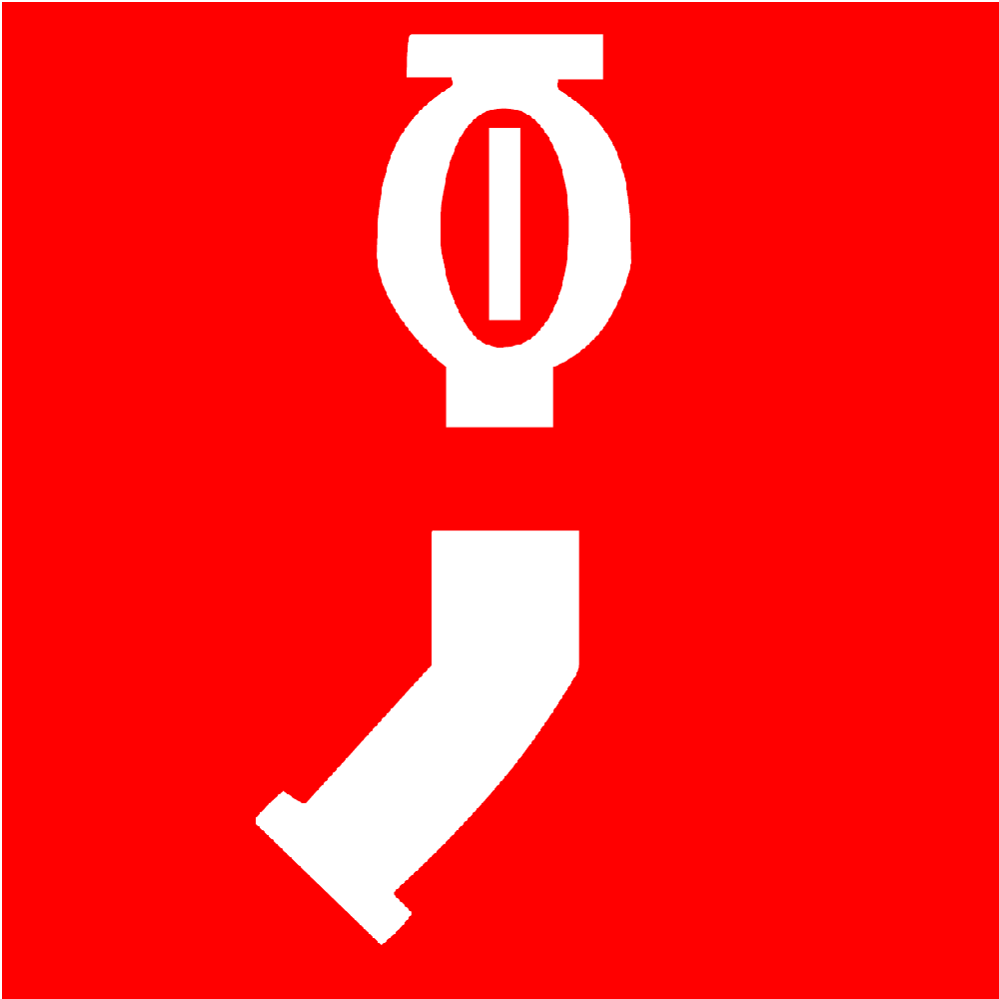 or 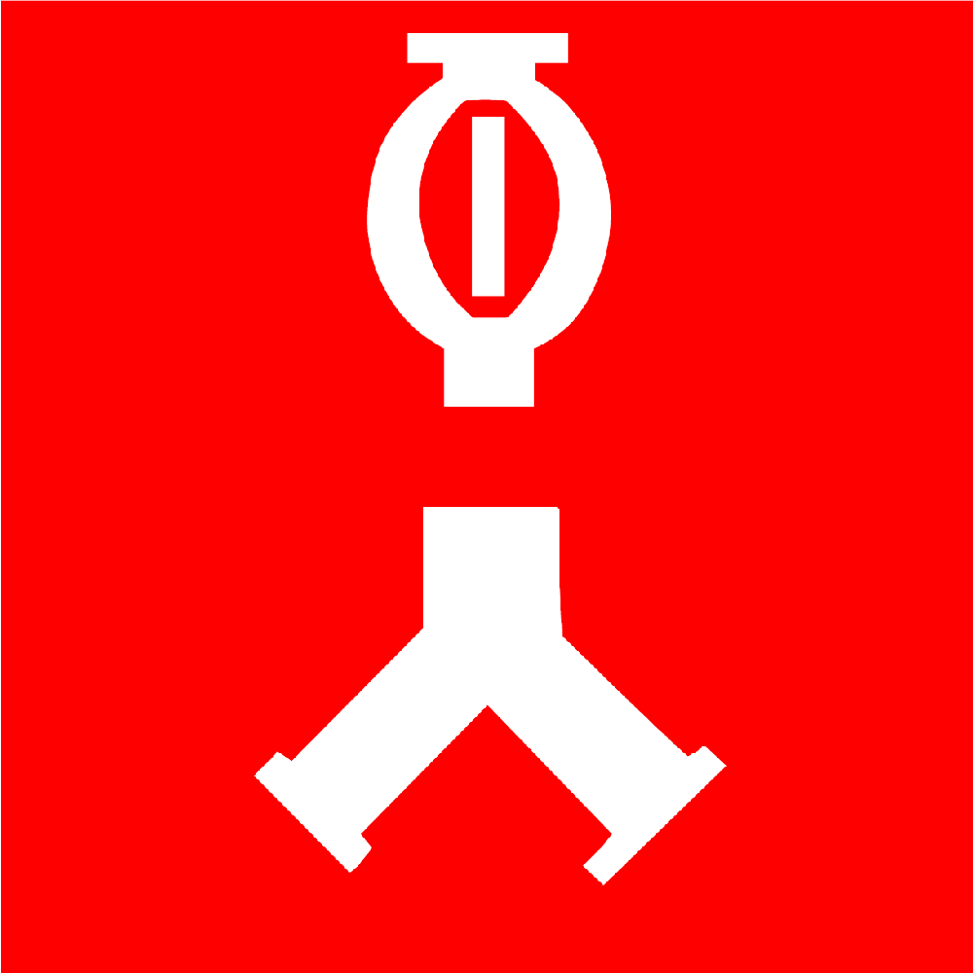

When supplying sprinkler systems installed in commercial or industrial facilities, maintain a pressure of 150 PSI through one single 3” hose, two 3” hose lines or one LDH – depending on the design of the system and the fire department connection (FDC) available.

When supplying sprinkler systems installed in residential occupancies, maintain a pressure of 150PSI through one single 1-3/4” hose or one single 3” hose depending on the design of the system and the FDC available.

** If the pump operator has to constantly increase PDP to maintain 150 PSI, the IC must be notified immediately**

Page 21

Standpipe Operations:
Standpipe systems installed or upgraded in Shenandoah Co. after 2008 shall be identified by the following signage:

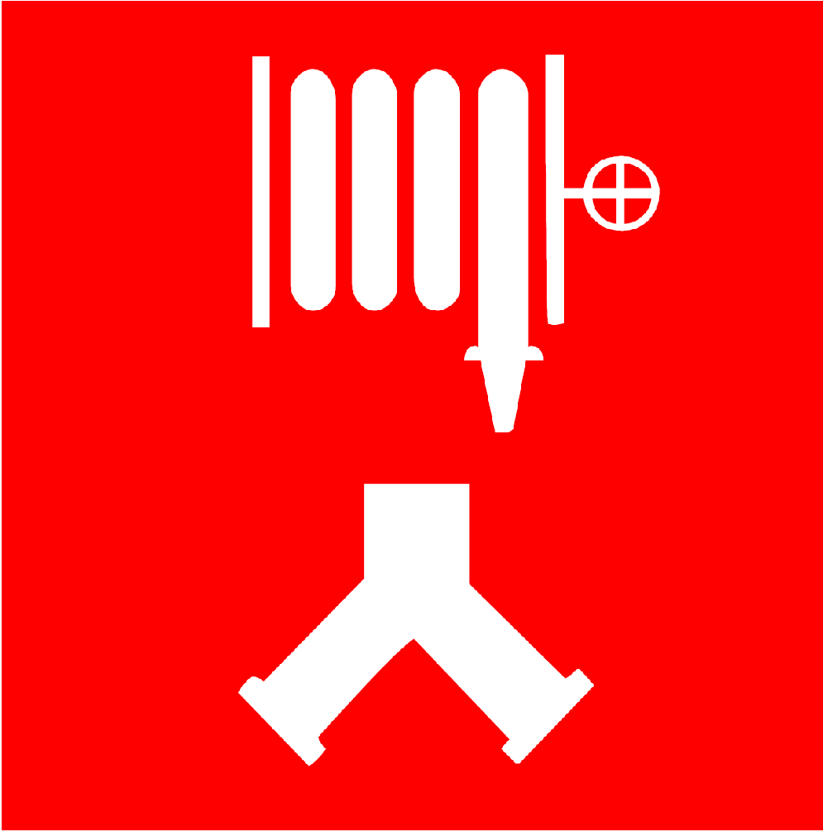

When supplying standpipe systems installed in commercial or industrial facilities, maintain a pressure of 175 PSI through, two 3” hose lines or one LDH – depending on the design of the system and the fire department connection (FDC) available.
Additional pressure may be needed to compensate for one or more of the following:
- Added friction loss for attack line on fire floor.
- Added friction loss for number of stories minus one floor.
- Added friction loss for supply hose connected to standpipe.

Page 22

Combination Sprinkler / Standpipe Operations:
Combination standpipe / sprinkler systems installed or upgraded in Shenandoah Co. after 2008 shall be identified by the following signage:



When supplying a combination sprinkler /standpipe systems installed in commercial or industrial facilities, maintain a pressure of 175 PSI through, two 3” hose lines or one LDH – depending on the design of the system and the fire department connection (FDC) available.

Additional pressure may be needed to compensate for one or more of the following:
- Added friction loss for attack line on fire floor.
- Added friction loss for number of stories minus one floor.
- Added friction loss for supply hose connected to standpipe.

Page 23

Ladder Pipe Operations:
When supplying ladder pipes:
- Attempt to position apparatus within 100’ of aerial device. (Try not to exceed 100’ of supply hose)
- Make sure detachable waterways are securely fastened prior to flowing water.
- Determine the nozzle pressure for master stream nozzle.
- Add 25 PSI for master stream device.
- Add friction loss for elevation (0.5 PSI per foot of elevation)
- Add friction loss for supply line going to aerial device.
** Add FL for hose line on ladder if not pre-piped**

Direct Fill Intakes:
When supplying apparatus through direct fill intakes, do not exceed 50-100 PSI while filling (check with manufacturers recommendations). These should only be used for filling the booster tank as part of rural water supply (shuttle) operations. Attack pumpers should not use them for relay operations or hydrant operations.

Page 24
Maintenance:
It is important to ensure that your pump is well maintained and in good working order to prevent costly repairs and malfunction during operations. You should always:

- Back flush the pump after drafting operations, starting with your highest discharge and flowing water through the pump, opening all discharges and intakes. Place 2 stage pumps in Volume (Series) Mode.
- Refill priming oil after drafting operations if applicable.
- Exercise all discharges/intakes when pump is not in gear on a weekly basis.
- Test pump by recirculating water at 150 PSI for 5 minutes on a weekly basis.
- Clean/inspect intake strainers, replace if needed and grease before reinstalling with lube plate type grease
- Check pump packing for any excessive leaks. (Some leakage is expected)

Additional Notes:

Page 25

Shenandoah County Fire & Rescue

Station Apparatus Specs
February 2019

Table of Contents

Conicville Vol. Fire Department …..……………..…..1

Edinburg Vol. Fire Company ……………………..….5

Fort Valley Vol. Fire Department …………….…..…12

Mt. Jackson Vol. Rescue & Fire Company ……...….16

New Market Vol. Fire & Rescue Company …….…..20

Orkney Springs Vol. Fire & Rescue ………………...23

Strasburg Volunteer Fire Department ……………...27

Toms Brook Vol Fire Department …….…………….31

Woodstock Vol Fire Department ……………………37

Engine 13

Make/Model
- 1988 Pierce Lance

Height/Length/Weight
- 9’ 6” / 27’ 3” / 40,000 lbs GVW

Motor Type
- Detroit Series 8V92

Tank Size
- 750 Gallons

Foam
- No on-board foam system, utilizes foam eductor
- 5 gallons of class A foam, Brand: National Foam – Responder Class A

Pump
- 1250 GPM, Model: Waterous
- 11 Discharges
- 7 Intakes
- Primer Type: Oil

Hose Loads
- Hose Brand: 1 ¾”, 2 ½”, and 3” – Kraken Exo Big Mtl, 4” - miscellaneous
- (2) 200’ 1 ¾” crosslays
- 100’ 1 ¾” bumper line
- 200’ 2 ½” rear discharge
- Leader Line – 150’ 2 ½” – Gated Wye - 150’ 1 ¾” preconnected
- 1000’ 4” supply line
- 800’ 3” supply line
- (2) 6” hard suction hoses, 10’ in length

Nozzle Types
- Task Force Tips
  - 1 ¾” fog – Akron 4814 Fog Nozzle 150 GPM/75 PSI with breakaway 15/16” smooth bore tip
  - 2 ½” – Akron smooth bore with 1 1/8” and 1 ¼” stacked tips
- Master Stream
  - Stacked tips – 2”, 1 ¾”, 1 ½”, 1 3/8”

Page 1
Engine 13 Cont.

Generator
- Current on-board generator is going to be replaced
- Briggs and Stratton 2,250 W – 120 V portable generator

Ladder sizes
- Attic Ladder – 10’
- Roof Ladders – 14’
- Extension Ladder – 24’

Saw types
- Husqvarna Model 55 chainsaw with 50:1 fuel mix
- Dewalt electric (corded) reciprocating saw

Extinguishers
- (1) Water Can
- (1) Dry Chemical Extinguisher

Electrical equipment
- (2) portable extension cords
- Assorted electrical adapters

Light equipment
- 2 mounted quartz lights
- 1 portable quartz light

Portable Equipment
- Electric negative pressure fan

Page 2

Wagon 13

Make/Model
- 2004 Spartan/Smeal

Height/Length/Weight
- 10’ 4” / 30’ 6” / 47,000 GVW

Motor Type
- Cummins ISL400

Tank Size
- 1000 Gallons

Foam
- Akron on-board foam sytem, 40 gallon tank
- Brand: National Foam-Responder Class A

Pump
- 1500 GPM, Model: Waterous
- 10 Discharges
- 5 Intakes
- Primer Type: Oil

Hose Loads
- Hose Brand: 1 ¾”, 2 ½”, 3” – Kraken Exo Big Mtl
- (2) 200’ 1 ¾” crosslays
- 100’ 1 ¾” bumper line
- 200’ 2 ½” rear discharge
- 1000’ 4” supply line
- 600’ 3” supply line
- (2) 6” hard suction hoses, 10’ in length
- (2) 2 ½” hard suction hoses, 10’ in length

Nozzle Types
- 1 ¾” – Akron 4814 fog nozzle, 150 GPM @ 75 PSI; breakaway smooth bore 15/16” tip
- 2 ½” – TFT smooth bore with 1 ½” tip
- Master Stream
  - Stacked tips – 2”, 1 ¾”, 1 ½”, 1 3/8”

Generator
On Board: Harrison 10 KW

Page 3
Wagon 13 Cont.

Ladder sizes
- Attic Ladder – 10’
- Roof Ladder – 14’
- Extension Ladder – 24’

Saw types
- Stihl MS290 Chainsaw

Extinguishers
- (1) Water Can
- (1) Dry Chemical Extinguisher
- (1) CO2 Extinguisher

Electrical equipment
- On board cord reel
- Assorted electrical adapters

Light equipment
- 2 mounted quartz lights
- 1 portable quartz light

Portable Equipment
- Electric negative pressure fan

Page 4

Rescue Engine 15

Make/Model
- 2009 Pierce Arrow XT PUC

Height/Length/Weight
- 10’ 5” / 32’9” / 49,800 GVW

Motor Type
- Detroit Series 60

Tank Size
- 750 Gallons

Foam
- On board Husky 12 Foam System
- 40 gallon Class A and 40 gallon Class B foam capacity
  - Class A Foam: Chemguard Plus
  - Class B Foam: Ansul TStorm AR-AFFF

Pump
- 1250 GPM, Model: Pierce PUC (pump and roll capability)
- 11 Discharges
- 4 Intakes
- Primer Type: Air

Hose Loads
- Hose Brand: miscellaneous
- (2) 200’ 1 ¾” crosslays
- 200’ 2 ½” crosslay
- 150’ 1 ¾” bumper line
- 200’ 2 ½” rear discharge
- 1000’ 5” supply line
- 800’ 3” supply line
- (2) 6” hard suction hoses, 10’ in length

Nozzle Types
- 1 ¾” Fog – TFT Mid-Matic @ 100 PSI
- 2 ½” Crosslay – TFT automatic fog
- 2 ½” Rear – Akron/Elkhart smooth bore nozzle w/ ½” and 15/16” tips
- Master Stream
  - Stacked tips – 2”, 1 ¾”, 1 ½”, 1 3/8”

Page 5

Rescue Engine 15 Cont.

Generator
- Harrison 15 KW Hydraulic PTO generator

Ladder sizes
- Attic Ladder – 10’
- Roof Ladder – 14’
- Extension Ladder – 24’
- Little Giant ladder

Saw types
- Stihl 180C Chainsaw
- Stihl TS400 Rotary Saw

Extinguishers
- Water Can
- Dry Chemical Extinguisher
- CO2 Extinguisher

Electrical equipment
- 2 – 100’ On board cord reels
- Assorted electrical adapters

Light equipment
- 2 mounted quartz lights
- 2 portable quartz lights
- Willburt Night Scan Light Tower
- (2) 1000 W tripod lights

Hydraulic Equipment
- Genesis on-board pump
- Genesis portable pump
- CR1108 Combi-Tool with 100’ hose reel on front bumper
- (2) Preconnected 100’ hydraulic hose reels
- (2) 31” Rams with accessory kits
- S35EF Spreader
- C130 Cutters
- C30 Pedal Cutter

Page 6

Rescue Engine 15 Cont.

Portable Equipment
- 9000 lbs. WARN Winch with anchor points on all 4 sides
- (2) 12 ton airbags
- (1) 10.8 ton airbag
- (2) Rescue Jacks with 4,000 lbs. working load limit
- (1) Rescue Jack stand-alone strut
- (2) farm jacks
- Gas powered PPV fan
- Electric negative pressure fan

Page 7

Pumper 15

Make/Model
- 1989 Spartan/FMC
- Refurbished in 2016

Height/Length/Weight
- 10’ 10” / 31’4” / 43,000 GVW

Motor Type
- Detroit Series 92 – 8V92TA

Tank Size
- 1500 Gallons

Foam
- No on-board foam system, utilizes foam eductor (95 GPM)
- 5 gallons of class A foam, Brand: Chemguard Plus

Pump
- 1250 GPM, Model: Hale
- 10 Discharges
- 3 Intakes
- Primer Type: Oil

Hose Loads
- Hose Brand: miscellaneous
- (2) 200’ 1 ¾” crosslays
- 150’ 1 ¾” bumper line
- 200’ 2 ½” rear discharge
- 800’ 3” supply line
- (2) 6” hard suction hoses, 10’ in length
- (2) 2 ½” hard suction hoses, 10’ in length

Nozzle Types
- 1 ¾” Fog – TFT Mid-Matic @ 100 PSI
- 2 ½” Fog – TFT H2Blitz Fog Model #H566213
- Master Stream
  - Stacked tips – 2”, 1 ¾”, 1 ½”, 1 3/8”

Generator
- Harrison 4.8KW Hydraulic PTO generator

Page 8
Pumper 15 Cont.

Ladder sizes
- Attic Ladder – 10’
- Roof Ladder – 14’
- Extension Ladder – 35’

Saw types
- Stihl 180C Chainsaw

Extinguishers
- Water Can
- Dry Chemical Extinguisher
- CO2 Extinguisher

Electrical equipment
- Assorted electrical adapters

Light equipment
- 2 mounted quartz lights
- 2 portable quartz lights

Portable Equipment
- Gas powered PPV
- Negative pressure fan

Page 9

Wagon 15

Make/Model
- 2004 Pierce Dash

Height/Length/Weight
- 9’ 9” / 31’9” / 49,800 GVW

Motor Type
- Detroit Series 60

Tank Size
- 1000 Gallons

Foam
- On board Husky 10 Foam System
- 40 gallon Class A and 40 gallon Class B foam capacity
  - Class A Foam: Chemguard Plus
  - Class B Foam: Ansul TStorm AR-AFFF

Pump
- 1500 GPM, Model: Hale
- 10 Discharges
- 5 Intakes
- Primer Type: Air

Hose Loads
- Hose Brand: miscellaneous
- (2) 200’ 1 ¾” crosslays
- 200’ 2 ½” crosslay
- 150’ 1 ¾” bumper line
- 200’ 2 ½” rear load with gated wye with 200’ 1 ¾”
- 1000’ 4” supply line
- 800’ 3” supply line
- (2) 6” hard suction hoses, 10’ in length
- (2) 2 ½” hard suction hoses, 10’ in length
- 100’ high rise pack

Nozzle Types
- 1 ¾” fog – TFT Mid-Matic @ 100 PSI
- 1 ¾” on high-rise pack & rear preconnect – Akron Turbojet Fog Model 1715
- 2 ½” – TFT automatic fog
- Master Stream
  - Stacked tips – 2”, 1 ¾”, 1 ½”, 1 3/8”

Page 10
Wagon 15 Cont.

Generator
- Harrison 10 KW Hydraulic PTO generator

Ladder sizes
- Attic Ladder – 10’
- Roof Ladder – 14’
- Extension Ladder – 24’
- Little Giant ladder

Saw types
- Stihl 025 Chainsaw
- Stihl TS350 SUPER Rotary Saw

Extinguishers
- Water Can
- Dry Chemical Extinguisher
- CO2 Extinguisher

Electrical equipment
- (2) – 100’ On board cord reels
- Assorted electrical adapters

Light equipment
- 2 mounted quartz lights
- 2 portable quartz lights
- Willburt Night Scan Light Tower
- (2) 1000 W tripod lights

Portable Equipment
- Electric negative pressure fan
- Electric PPV fan

Page 11
Engine 14

Make/Model
- 2005 Pierce/International

Height/Length/Weight
- 9’ 4” / 29’ 9” / 38,000 lbs. GVW

Motor Type
- IHC DT570

Tank Size
- 1000 Gallons

Foam
- No on-board foam system, utilizes POK AFFF foam sticks

Pump
- 1000 GPM, Model: Waterous
- 7 Discharges
- 3 Intakes
- Primer Type: Electric (No oil)

Hose Loads
- Hose Brand: Misc
- (2) 200’ 1 ¾” crosslays
- 200’ 2 ½” rear discharge
- 1000’ 3” supply line
- (2) 6” hard suction hoses, 10’ in length

Nozzle Types
- 1 ¾” – Akron Combination Nozzle, Style 1523 ¾” outlet
- 2 ½” – Akron Combination Nozzle, Style 1526 7/8” outlet

Generator
On Board: Harrison 8 KW

Ladder sizes
- Attic Ladder – 10’
- Roof Ladder – 14’
- Extension Ladder – 24’

Saw types
- Cutters Edge CE-2171-RS Chainsaw, Fuel: Synthetic 100:1 mix, petroleum 50:1

Page 12

Engine 14 Cont.

Extinguishers
- (1) Water Can
- (1) Dry Chemical Extinguisher
- (1) CO2 Extinguisher

Electrical equipment
- 200’ on board cord reel
- (2) 100’ portable cord reels

Light equipment
- 2 mounted quartz lights
- 2 portable quartz lights
- 2-light portable construction lights

Portable Equipment
- Genesis hydraulic pump with cutters/spreaders/combi-tool

Page 13

Pumper 14

Make/Model
- 1997 Pierce/Freightliner

Height/Length/Weight
- 9’ 4” / 27’ 7” / 38,000 lbs. GVW

Motor Type
- Cummins C8.3-325

Tank Size
- 1000 Gallons

Foam
- On-board foam sytem, 40 gallon tank
- Brand: ?

Pump
- 1000 GPM, Model: Waterous
- 6 Discharges
- 3 Intakes
- Primer Type: Oil

Hose Loads
- Hose Brand: Misc
- (2) 200’ 1 ¾” crosslays
- 200’ 2 ½” rear discharge
- 1000’ 3” supply line
- (2) 6” hard suction hoses, 10’ in length

Nozzle Types
- 1 ¾” – Akron Combination Nozzle, Style 1523 ¾” outlet
- 2 ½” – Akron Combination Nozzle, Style 1526 7/8” outlet

Generator
On Board: Honda EM 5000S – 5 KW

Ladder sizes
- Attic Ladder – 10’
- Roof Ladder – 14’
- Extension Ladder – 24’

Page 14

Pumper 14 Cont.

Saw types
- Cutters Edge CE-2171-RS Chainsaw, Fuel: Synthetic 100:1 mix, petroleum 50:1
- Stihl TS400 Rotary Saw, Fuel: 50:1

Extinguishers
- (1) Water Can
- (1) Dry Chemical Extinguisher
- (1) CO2 Extinguisher

Electrical equipment
- (2) 100’ portable cord reels

Light equipment
- 2 mounted quartz lights
- 1 portable LED quartz light
- UtiliTech LED portable light

Portable Equipment
- (2) Electric negative pressure fan

Page 15

Engine 21

Make/Model
- 1989 Pierce Lance

Height/Length/Weight
- 9’ 10” / 27’10” / 34,140 GVW

Motor Type
- Detroit Series 60

Tank Size
- 750 Gallons

Foam
- No on-board foam system, utilizes foam eductor
- 10 gallons of class A foam, Brand: Silv-Ex

Pump
- 1250 GPM, Model: Waterous
- 11 Discharges
- 4 Intakes
- Primer Type: Oil

Hose Loads
- Hose Brand: Miscellaneous
- (3) 200’ 1 ¾” crosslays
- 100’ 1 ¾” high rise pack
- 100’ 1 ¾” bumper line
- 200’ 2 ½” rear discharge
- Leader Line – 200’ 2 ½” – Gated Wye - 200’ 1 ¾” preconnected
- 1000’ 4” supply line
- 700’ 3” supply line
- (2) 6” hard suction hoses, 10’ in length

Nozzle Types
- Task Force Tips
  - 1 ¾” – Metro 1, 200 GPM @ 75 PSI; breakaway smooth bore 1” tip
  - 2 ½” – Smooth bore with 1 ¼” and 1 ½” stacked tips
- Master Stream
  - Stacked tips – 2”, 1 ¾”, 1 ½”, 1 3/8”

Generator
- Onon 3DJRFJ – 3 KW

Page 16

Engine 21 Cont.

Ladder sizes
- Attic Ladder – 10’
- Roof Ladder – 14’
- Extension Ladder – 24’

Saw types
- Stihl MS311 Chainsaw
- Stihl TS400 K12 Saw

Extinguishers
- (1) Water Can
- (2) Dry Chemical Extinguisher

Electrical equipment
- On board cord reel
- (1) 100’ portable extension cord
- Assorted electrical adapters

Light equipment
- 2 mounted LED quartz lights
- 1 portable quartz light

Portable Equipment
- Electric negative pressure fan

Page 17

Pumper 21

Make/Model
- 1996 Pierce Dash

Height/Length/Weight
- 10’ / 31’2” / 40,120 lbs GVW

Motor Type
- Detroit Series 60

Tank Size
- 1000 Gallons

Foam
- No on-board foam system, utilizes foam eductor
- 10 gallons of class A foam, Brand: Silv-Ex

Pump
- 1500 GPM, Model: Hale
- 10 Discharges
- 4 Intakes
- Primer Type: Oil

Hose Loads
- Hose Brand: Miscellaneous
- (4) 200’ 1 ¾” crosslays
- 100’ 1 ¾” bumper line
- 200’ 2 ½” rear discharge
- Leader Line – 200’ 2 ½” – Gated Wye - 200’ 1 ¾” preconnected
- 1000’ 4” supply line
- 700’ 3” supply line
- (2) 6” hard suction hoses, 10’ in length

Nozzle Types
- Task Force Tips
  - 1 ¾” Fog – Metro 1, 200 GPM @ 75 PSI; breakaway smooth bore 1” tip
  - 1 ¾” Smooth Bore – 15/16” tip
  - 2 ½” – Smooth bore with 1 ¼” and 1 ½” stacked tips
- Master Stream
  - Stacked tips – 2”, 1 ¾”, 1 ½”, 1 3/8”

Generator
- Onon 3DJRFJ – 3 KW

Page 18

Pumper 21 Cont.

Ladder sizes
- Attic Ladder – 10’
- Roof Ladder – 14’, 16’
- Extension Ladder – 24’

Saw types
- Stihl MS311 Chainsaw
- Stihl TS400 K12 Saw

Extinguishers
- (1) Water Can
- (2) Dry Chemical Extinguisher

Electrical equipment
- On board cord reel
- (1) 100’ portable extension cord
- Assorted electrical adapters

Light equipment
- 4 mounted quartz lights
- 1 portable quartz light

Portable Equipment
- Electric negative pressure fan

Page 19
Engine 23

Make/Model
- 1994 Pierce Saber Pumper

Height/Length/Weight
- 10’ / 29’ / 39,000 GVW

Motor Type
- 6 Cyl. International Diesel

Tank Size
- 1000 Gallons

Foam
- On board Foam System – Feecon Model AP 1.0-A
- 35 gallons of class A foam, Brand: Chem-Guard

Pump
- 1250 GPM Single Stage Waterous Pump
- 9 Discharges
- 4 Intakes
- Primer Type: Oil (SAE-30 Non Detergent Motor Oil)

Hose Loads
- Hose Brand: Miscellaneous but mostly National
- (1) 200’ 1 ¾” crosslay
- (1) 250’ 1 ¾” crosslay
- 100’ 1 ¾” high rise pack Double Doughnut Roll
- 100’ 1 ¾” Trash Line
- 200’ 2 ½” Blitz Line
- 250’ 2” Commercial Line
- 1000’ 4” supply line
- 1000’ 3” supply line
- (2) 6” hard suction hoses, 10’ in length
- 100’ 1” Forestry Line

Page 20
Engine 23 Cont.

Nozzle Types
- TFT Metro 1
  - 1 ¾” Fog 185 GPM / 50PSI
  - 15/16 Smooth Bore Tip 185 GPM / 50 PSI
  - 2” Straight Bore Stack Tips (1 1/8, 1”)
  - 2 ½” Straight Bore 1 ¼” Tip
  - 1 ¾” Straight Bore 15/16” Tip
  - 1” Fog Nozzle

- Master Stream
  - Stacked tips – 2”, 1 ¾”, 1 ½”, 1 3/8”

Generator
- 7500 Watt Onan (Diesel Fuel)

Ladder sizes
- Attic Ladder – 10’
- Roof Ladder – 14’
- Extension Ladder – 24’

Saw types
- Stihl MS170 W/ 16” Bar Chainsaw
- Milwaukee W/ 9” Metal Cutting Blade Recipricating Saw

Extinguishers
- (1) Water Can
- (2) ABC
- (1) CO2

Electrical equipment
- (1) 50’ Light duty Extension Cord
- (1) 100’ Heavy Duty Extension Cord

Light equipment
- 6 Fixed Lights – 750 Watt Manual Poles (Fixed to Cab)
- 2 Portable ground lights W/ 500 Watt Halogen
- (1) 50’ Heavy duty cord on hand reel W/ 750 – Watt ground light

Portable Equipment
- Electric positive pressure fan

Page 21
Engine 23 Cont.

Extrication Equipment
- 10,500 PSI System (Mineral Oil)
- HYD. Spreader
- HYD. O Cutter
- HYD. Combi-Tool
- HYD. Rams (1 small, 1 large w/ 2 Steel Door Ram Supports
- 2 Hydraulic Hoses (attached to pump), 1 Hydraulic Hose on hand reel
- 3 – 20’ Hoses

Stabilization
- 2 Kodiak Struts
- 1- Picket Guide Plate w/ (3) 15” Steel pickets
- (2) 2” Ratchet Type Straps
- (1) 1 Ton Come-along (Cable Type)
- Cribbing

Page 22
Tanker 18

Make/Model
- S&S Spartan

Length/Weight
- 31’ 1” / 54,000

Motor Type
- Detriot 60 Series

Tank Size
- 1900 Gallons with direct fill

Foam
- 50 Gallon Tank
- “Firepower” brand class A

Pump
- 1500 GPM Hale
- 9 Discharges
- 3 Intakes (Do not count direct fill)

Hose Loads
- (2) 200’ 1 ¾” crosslays
- 200’ 2 ½” crosslay
- 100’ 1 ¾” “trashline” at the pump panel
- 1500’ 3” supply line (each color = 500’)
- (2) 6” hard suction hoses, 10’ in length

Nozzle Types
- Akron Combination Nozzles
  - 1 ¾” – Style 1523 ¾” outlet
  - 2 ½” – Style 1526 7/8” outlet
- Master Stream
  - (2) 100 PSI adjustable 500-1300 GPM

Generator
- Honda 5000 5 KW

Ladder sizes
- 9’ Attic ladder
- 14’ Roof ladder
- 24” Extension ladder

Page 23

Tanker 18 Cont.

Saw types
- Partner K12. Mixed fuel ratio 50:1
- Ventilation saw
  - Cutters Edge. Mixed fuel ratio 50:1

Extinguishers
- (1) Water Can
- (1) CO Extinguisher
- (2) Dry Chemical Extinguishers

Electrical equipment
- 200’ onboard cord reel
- 50’ portable cord reel
- (2) 25’ portable cord reels

Light equipment
- (2) Portable quartz lights (rear of apparatus)
- (2) Fixed quartz lights (rear of cab)
- (4) Box lights (inside cab)
- (6) “Survivor Lights” (inside cab)

Hydraulic equipment
- Hand powered hydraulic spreader

Page 24

Engine 18

Make/Model
- Smeal/Spartan

Height/Length/Weight
- 10’ / 28’1” / 44,000 GVW

Motor Type
- Detroit Series 60

Tank Size
- 750 Gallons with direct fill

Foam
- 25 gallon tank
- “Firepower” brand class A
- Foam Sticks
  - Green – Class A
  - Red – Class B

Pump
- 1500 GPM Hale QMax
- 10 Discharges
- 3 Intakes (Do not count direct fill)

Hose Loads
- 100’ Booster reel
- (2) 200’ 1 ¾” crosslays
- 200’ 2 ½” rear discharge
- Leader Line – 200’ 2 ½” – Gated Wye - 100’ 1 ¾” preconnected
100’ 1 ¾” dead load
- 1500’ 4” supply line (each color = 500’)
- 1500’ 3” supply line (each color = 500’)
- (2) 6” hard suction hoses, 10’ in length

Nozzle Types
- Akron Combination Nozzles
  - Booster reel – Style 1512 ½” outlet
  - 1 ¾” – Style 1523 ¾” outlet
  - 2 ½” – Style 1526 7/8” outlet
- Master Stream
  - 100 PSI adjustable 500-1300 GPM
  - Stack tips

Page 25
Engine 18 Cont.

Generator
- Honda PTO 5 KW

Ladder sizes
- Attic Ladder – 10’
- Roof Ladder – 14’
- Extension Ladder – 24’

Saw types
- Ventilation Saw
  - Cutters Edge. Mixed Fuel Ration 50:1.

Extinguishers
- (1) Water Can
- (1) Dry Chemical Extinguisher
- (1) CO Extinguisher

Electrical equipment
- 200’ on board cord reel
- (2) 100’ portable extension cords

Light equipment
- (2) fixed quartz lights (rear of cab)
- (2) portable quartz lights (rear of engine)
- (4) box lights (inside cab)
- (6) “Survivor” Lights (inside cab)

Hydraulic equipment
- Onboard/portable genesis hydraulic pump
- Onboard 100’ hose reel
- Genesis Combi-Tool

Page 26

Wagon 51

Make/Model
- 2016 Pierce Arrow XT

Height/Length/Weight
- 9’ 7” / 32’ 2” / 42,480 lbs GVW

Motor Type
- 500 HP Cummins ISX12

Tank Size
- 1000 Gallons

Foam
- No on-board foam system, utilizes foam eductor
- 5 gallons of class A foam, Brand: National Foam
- 15 gallons of Class B foam, Brand: Universal Plus

Pump
- 1500 GPM, Model: Single Stage Waterous Pump
- 9 Discharges
- 5 Intakes
- Primer Type: Air

Hose Loads
- Hose Brand: Key Hose (1 3/4” FDNY Spec) (2”, 3”, 4” Combat Ready Spec)
- (2) 200’ 1 ¾” crosslays
- 100’ 1 ¾” bumper line
- 250’ 2” Key Hose
- Leader Line – 200’ 2 ½” – Gated Wye - 200’ 1 ¾” preconnected
- 1000’ 4” supply line
- 1000’ 3” supply line
- High Rise Pack – 200’ 1 3/4” with 6’ 3” connected to gated wye
- (2) 6” hard suction hoses, 10’ in length

Nozzle Types
- Elkhart Brass Model – Chief 4000-24
  - 1 3/4” Fog Setting 185 GPM / 75 PSI
  - Smoothbore Breakaway setting – 1” tip 200 GPM / 50 PSI
- Master Stream
  - Stacked tips – 2”, 1 ¾”, 1 ½”, 1 3/8”

Page 27

Wagon 51 Cont.

Ladder sizes
- Attic Ladder – 10’
- Roof Ladder – 16’
- Extension Ladder – 28’

Saw types
- Stihl MS290 W/ 16” Bar Chainsaw

Extinguishers
- (1) Water Can
- (1) ABC
- (1) CO2

Electrical equipment
- On board cord reel
- (1) 100’ portable extension cord
- Assorted electrical adapters

Light equipment
- Fixed – 4 LED Scene Lights. 2 Adjustable, 1 Brow light and 1 fixed above rear compartment

Portable Equipment
- Battery Powered Positive Pressure Fan

Page 28
Pumper 51

Make/Model
- 1989 Seagrave Model: JB-40DH

Height/Length/Weight
- H: 11’ 6” L: 31’ W:

Motor Type
- Detroit Series 60

Tank Size
- 1250 Gallons

Foam
- No on board foam system, uses foam eductor
- 5 Gallons of class A foam, Brand: Silvex
- 15 Gallons of class B foam, Brand: Universal Plus
- Foam Pro Pak

Pump
- 1250 GPM, Model: Waterous
- Discharges 11
- Intakes 5

Hose Loads
- Hose Brand: Key hose – (1 ¾” FDNY Spec) (2”, 3”, 4” Combat Ready Spec)
- 150’ 1 ¾” bumper line
- (2) 200’ 1 ¾” crosslays
- 200’ 2” rear crosslay (Driver Side Green)
- Leader Line - 200’ 2 ½ / 200’ 1 ¾ with gated wye (Officer Side Blue)
- 1000’ 4” supply line
- 500’ 3” supply line
- (2) 6” hard suction hoses, 10’ in length
- 3” hard suction hose, 10’ in length

Page 29
Pumper 51 Cont.

Nozzle Types
- Elkhart Brass, Model – Chief 4000-42
    - 1 ¾”
  - Fog setting - 185 GMP/75psi
  - Smoothbore breakaway setting – 1” tip (200 GPM)/ 50 psi
    - 2”
  - Smoothbore 1 ¼” tip
- Master Stream
  - Stack tips 2”, 1 ¾”, 1 ½”, 1 3/8”
  - Fog 100 PSI, 350-1000 GPM

Generator
- No on-board Generator

Ladder sizes
- Attic Ladder – 10’
- Roof Ladder – 14’
- Extension Ladder – 24’

Portable Equipment
- Portable Pump – Honda WT30, 300 GPM
  - Fuel: Ethanol Free gas, 94 Octane

Extinguishers
- CO Extinguisher
- ABC Extinguisher
- Water Can

Light equipment
- 2 Top pump mounted LED Quartz Lights

Page 30
Wagon 9

Make/Model
- 1996 Pierce Quantum

Height/Length/Weight
- 10’ / 32’ / 39,780 lbs. GVW

Motor Type
- Detroit Series 60

Tank Size
- 1000 Gallons

Foam
- On board foam system
- 20 gallons of class A foam, Brand: Red Alert

Pump
- 1250 GPM, Model: Waterous
- 11 Discharges
- 4 Intakes
- Primer Type: Oil

Hose Loads
- Hose Brand: Miscellaneous
- (2) 200’ 1 ¾” crosslays
- 200’ 1 ¾” bumper line
- 300’ 1 ¾” rear discharge
- 1000’ 4” supply line
- 200’ 3” supply line
- (3) 6” hard suction hoses, 10’ in length

Nozzle Types
- Task Force Tips
  - 1 ¾” – Fog: H-210830 Automatic GPM nozzle @ 75 psi
  - 1 ¾” – Smooth Bore: KKF-236869 1 ¼” tip
- Piped for master stream, but no deck gun attached

Generator
- Kubota D1005-E, 8 KW on board

Page 31

Wagon 9 Cont.

Ladder sizes
- Attic Ladder – 10’
- Roof Ladder – 14’
- Extension Ladder – 24’

Saw types
- Stihl 025 Chainsaw with 50:1 fuel mix
- Echo QV-8000 chainsaw with 50:1 fuel mix

Extinguishers
- (1) Water Can
- (1) Dry Chemical Extinguisher
- (1) CO2 extinguisher

Electrical equipment
- On board cord reel – 200’

Light equipment
- 2 top mounted quartz lights
- 2 rear mounted quartz lights

Portable Equipment
- Electric negative pressure fan

Page 32

Engine 9

Make/Model
- 2002 Pierce Dash

Height/Length/Weight
- 10’ 10” / 35’ 3” / 49,100 lbs. GVW

Motor Type
- Cummins ISM450

Tank Size
- 750 Gallons

Foam
- On board foam system
- 30 gallons of class A foam, Brand: Red Alert

Pump
- 2000 GPM, Model: Hale
- 12 Discharges
- 4 Intakes
- Primer Type: Air on front and steamer intakes

Hose Loads
- Hose Brand: Miscellaneous
- (2) 200’ 1 ¾” crosslays
- 300’ 1 ¾” crosslay
- 400’ 1 ¾” rear discharge
- 200’ 1 ¾” bumper line
- 200’ 2 ½” rear discharge
- 1000’ 5” supply line
- 1000’ 4” supply line
- 500’ 3” supply line
- (4) 6” hard suction hoses, 10’ in length

Nozzle Types
- Akron
  - 1 ¾” – Fog: Model 4817 150 GPM @ 75 PSI
  - 2 ½” – Fog: Assault 4827 200 GPM @ 75 PSI
- Master Stream
  - 1250 GPM adjustable fog

Generator
- Harrison 20 KW generator

Page 33

Engine 9 Cont.

Ladder sizes
- Attic Ladder – 10’
- Roof Ladder – 14’
- Extension Ladder – 24’

Saw types
- 2 corded electric reciprocating saws

Extinguishers
- (1) Water Can
- (1) Dry Chemical Extinguisher
- (1) CO2 extinguisher

Electrical equipment
- On board cord reel – 200’

Light equipment
- Top mounted light tower
- 4 top mounted quartz lights

Portable Equipment
- Electric positive pressure fan
- Honda EV 2000 portable generator

Hydraulic Equipment
- (4) 100 ft. on board cord reels
- Amkus Spreaders
- (2) Amkus Cutters
- (4) Amkus Rams
- Amkus Combi-Tool
- Amkus portable pump
- (2) 50 ft. portable hydraulic lines

Page 34

Tanker 9

Make/Model
- 2005 Sterling/Seagrave

Height/Length/Weight
- 11’ 2” / 34’ 2” / 54,880 lbs. GVW

Motor Type
- CAT C-13 ACERT

Tank Size
- 3500 Gallons

Foam
- None

Pump
- 1750 GPM, Model: Hale
- 8 Discharges
- 3 Intakes
- Primer Type: Air

Hose Loads
- Hose Brand: Miscellaneous
- (2) 200’ 1 ¾” crosslays
- 200’ 2 ½” crosslay
- 50’ 4” supply line
- 550’ 3” supply line
- (2) 6” hard suction hoses, 10’ in length
- (2) 2 ½” hard suction hoses, 10’ in length

Nozzle Types
- 1 ¾” – TFT H-210830 Automatic GPM nozzle @ 75 psi
- 2 ½” – POK smooth bore with 1 1/8” tip
- Master Stream
  - Stacked tips: 2”, 1 ¾”, 1 ½”, 1 3/8”

Generator
- None

Ladder sizes
- None

Page 35

Tanker 9 Cont.

Saw types
- None

Extinguishers
- None

Electrical equipment
- None

Light equipment
- 2 top mounted quartz lights

Portable Equipment
- 3500 gallon dump tank

Page 36
Wagon 12
Make/Model
- 2013 Sutphen Monarch

Height/Length/Weight

Motor Type

Tank Size
- 1000 Gallon

Foam
- 40 Gallon Class A foam Cell
- (3) AFFF/ATC National foam buckets

Pump
- 1500 GPM Waterous Pump

Hose Loads
- 150’ 1 ¾” Front Trash Line
- (4) 200’ 1 ¾” Crosslays
- 2x high rise packs (100’1 ¾” with Elkhart low pressure nozzle, 100’ 2 ½”)
- 200’ 2 ½” Attack Line
- 150’ 3” Blitz Hose (with portable Elkhart Stinger monitor)
- 1400’ 4” Supply Hose
- 400’ 3” Supply Hose

Nozzle Types
- 1 ¾” fog nozzles Elkhart SM20
- 1 ¾” 15/16” smoothbore nozzles
- 2 ½” Elkhart SM 30 fog nozzles with playpipe
- 2 ½” Smoothbore Nozzle with Playpipe
- Foam nozzle with eductor (95 GPM)
- 2 ½” water distributer nozzle

Generator
- Harrison 10 kW generator

Page 37
Wagon 12 Cont.

Ladder sizes
- 28’ extension ladder
- 16’ roof ladder
- 10’ folding attic ladder

Saw types
- Sawz-all
- Stihl MS362 Chainsaw 16” bar

Extinguishers
- (2) 5 gallon water extinguishers
- 5lb Dry Chemical Extinguisher
- 20lb Dry Chemical Extinguisher
- 15lb CO2 Extinguisher

Electrical equipment
- Electric smoke ejector fan

Light equipment
- Quartz scene light with cord
- (2) circle D portable lights

Portable Equipment
- Gas 16” smoke ejector PPV fan

Hydraulic Equipment
- Porta-Power Tool

Page 38
Engine 12
Make/Model
- 1997 Freightliner FL70

Height/Length/Weight

Motor Type

Tank Size
- 500 Gallon Water Tank

Foam
- 30 gal. class A foam tank
- (3) National AFFF/ATC Foam Buckets

Pump
- 1000 GPM Darley Fire Pump

Hose Loads
- 200’ 1” forestry hose preconnected
- (2) 200’ 1 ¾” Attack Lines
- 400’ 3” Supply Hose
- 800’ 4” Supply Hose

Nozzle Types
- 1 ¾” Elkhart SM- 20 fog Nozzle
- 2 ½” Fog Nozzle Elkhart SM-30
- 2 ½” Smooth Bore Nozzle
- Foam nozzle w/ Eductor (95 GPM) Akron

Generator
- Onan 5000 Genset Generator

Ladder sizes
- 16’ Extension Ladder

Saw types
- Husqavarna chainsaw Model 345
- Porter Cable Sawz-all

Page 39
Engine 12 Cont.

Extinguishers
- (2) 5 Gallon Water Extinguishers
- (2) 10 lb Dry Chemical Extinguisher
- 15 lb CO2 Extinguisher

Electrical equipment
- 150’ Cord Reel w/ one Circle D junction box
- Small 100’ Cord Reel

Light equipment
- (2) Circle-D Portable Lights

Portable Equipment
- N/A

Hydraulic Equipment
- Honda simo pump
- 110 volt simo pump
- Combi-tool

Page 40
Rescue Engine 12
Make/Model
- 2007 Sutphen Monarch

Height/Length/Weight
- 10’ 9”/ 35’6”/ 46,740 lbs

Motor Type
- Caterpillar C-13 525 HP

Tank Size
- 750 gallon tank

Foam
- 40 Gallon Class A foam tank
- 95 gpm Akron Foam educator
- (2) 5 Gallon Bucket Class A National Foam
- (3) 5 Gallon Bucket Class B National Foam

Pump
- 1500 GPM Waterous Pump

Hose Loads
- 150’ 1 ¾” Trash Line
- (2) 200’ 1 ¾” Crosslays
- 150’ 2 ½” Crosslay
- 250’ 3” Leader line with gated wye
- 500’ 3” LDH supply hose
- 800’ 4” LDH supply hose
- 100’ 1 ¾” High rise pack with gated wye

Nozzle Types
- 1 ¾” Elkhart SM20 nozzles
- 1 ¾” Elkhart low pressure nozzle
- 2 ½” Elkhart SM 30 fog
- 95 gpm Foam Nozzle

Generator
- 20 kW Harrison PTO hydraulic generator

Ladder sizes
- 10’ attic ladder
- 14’ roof ladder
- 24’ extension ladder
Page 41
Rescue Engine 12 Cont.
Saw types
- Husqvarna chair saw 16” bar
- Husqvarna rotary saw 14” blade
- Dewalt battery sawz-all
- Tiger electric sawz-all

Extinguishers
- (2) Water Extinguisher
- 20 lb ABC Extinguisher
- 15 lb CO2 Extinguisher

Electrical equipment
- 100’ Electric reel with junction box

Light equipment
- Wilburt vertical light tower
- (2) Circle D lights
- Portable hanging light

Portable Equipment
- Electric fan with 25’ cord
- Air tool bottle & regulator
- Air bag control box and accessories
- Airbags 13 Ton, 22 Ton, 32 Ton
- Harness bag with carabiners, prussic, and 8-plates
- 150’ lifeline, pre-rigged 3:1 haul system
- (4) 15’ chains (12,000 lb rated)
- (2) Frame keys
- Paratech struts with adaptors, straps and base plates
- (2) Rescue Lift Jacks, 1 Rescue Jack (non-lift)
- Porter cable battery drill
- (2) Bottle Jack
- (2) Come-a-Long

Hydraulic Equipment
- Genesis electric trimo hydraulic pump
- Genesis gas portable simo hydraulic
- Genesis combi-tool (Front Bumper 65’ pre-connected)
- Genesis spreader
- Genesis cutter
- Genesis mini-cutter
- Genesis hydraulic rams w/ extension kit (31” & 41”)
Page 42

